

COMPUTER SCIENCE

SOURCE CODE MANAGEMENT

CSE2015

HANDLED BY : MONITH KAPOOR SIR

AMITY UNIVERSITY

BENGALURU

G SHREE RAKSHA

B TECH CSE

2ND SEM

A86605224340

Step 1 : Search for progit in chrome ,it will show this 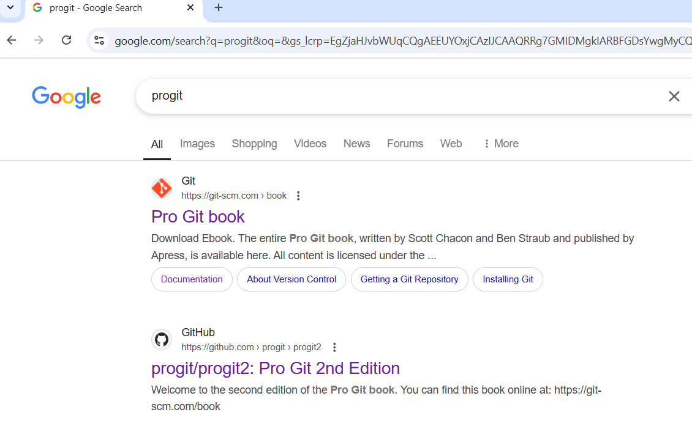

Now click on the first link shown on the page.

Step 2 : After opening the page ,you can see the download option.

You can choose how much bit is need for your laptop.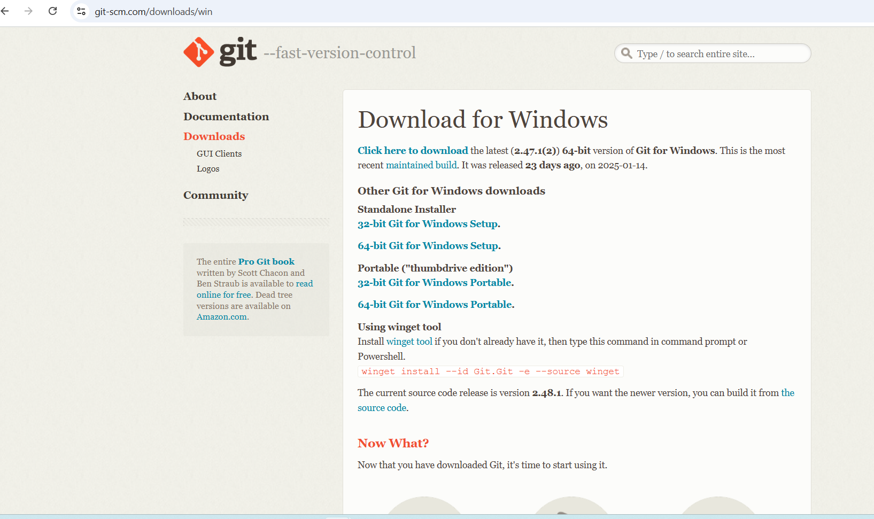

After the completion of download process , you can see the page like this ,that is general public license.

Step 3 :Now General public license page is opened.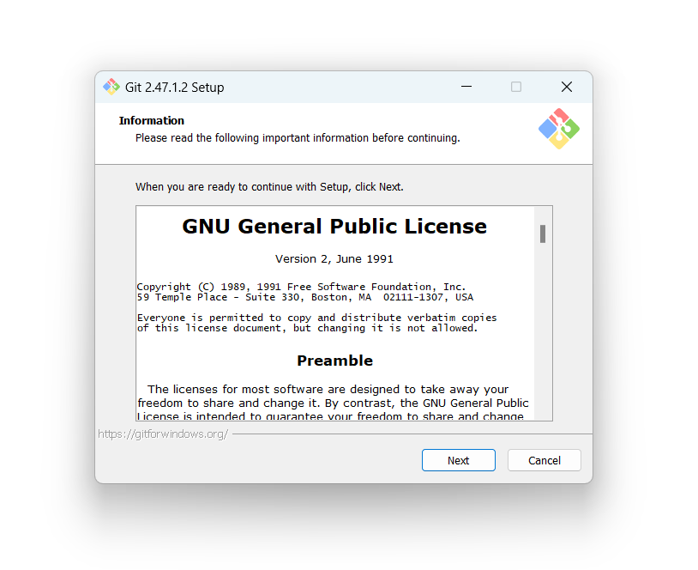

Click on the ‘next’ option for further procedure.

After clicking on “next”you can choose where you want the file to be installed.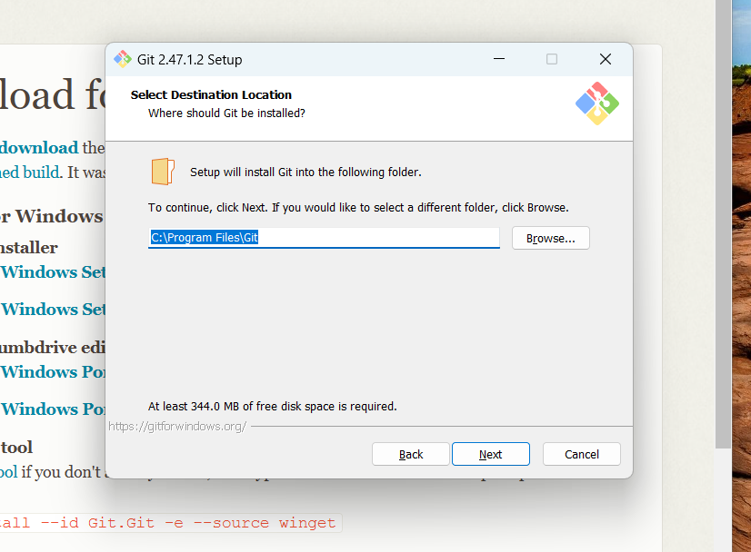

After this process,you should select the components to be install in git.

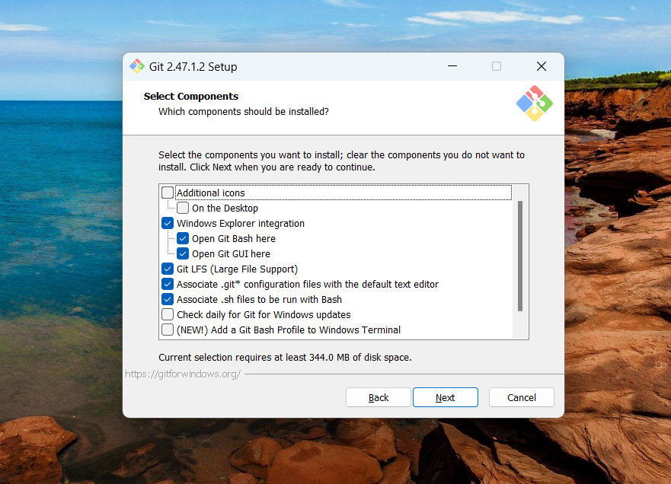

After choosing the options you will be asked for creating an short cut and where to save it.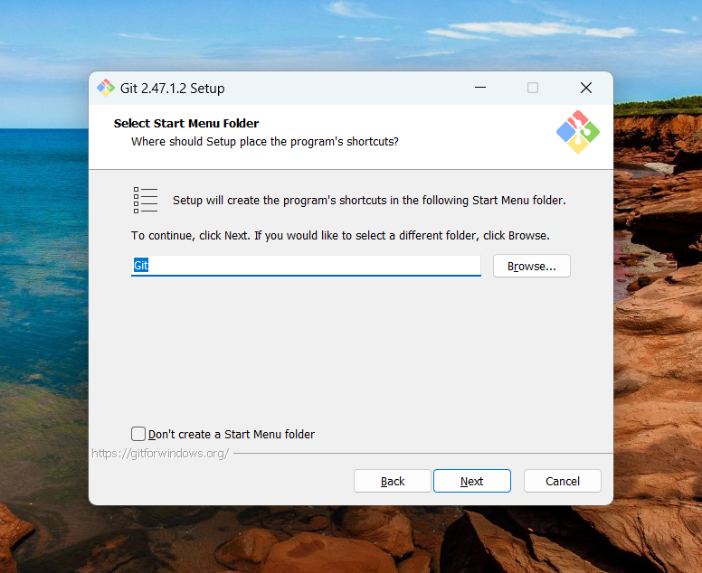

Now you choose the text editor for git use .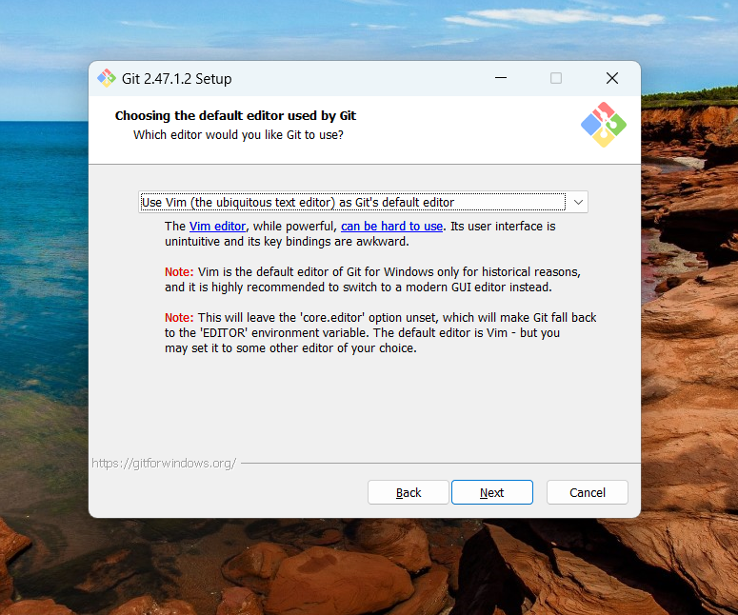

Now here you can choose the initial branch name.

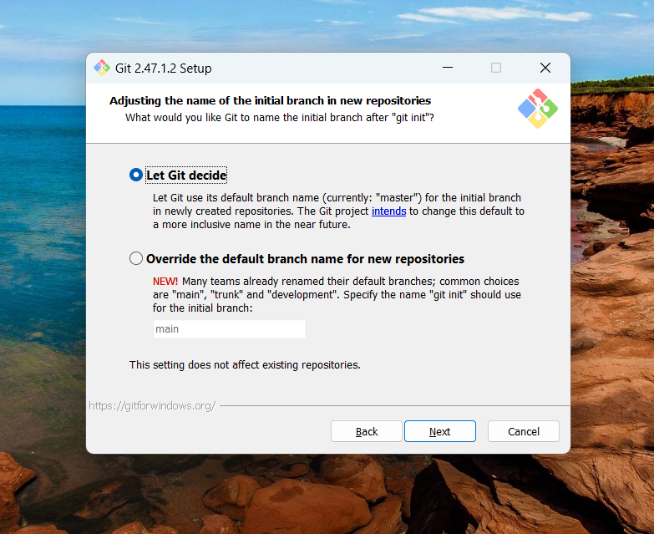Here path is creating for git use.

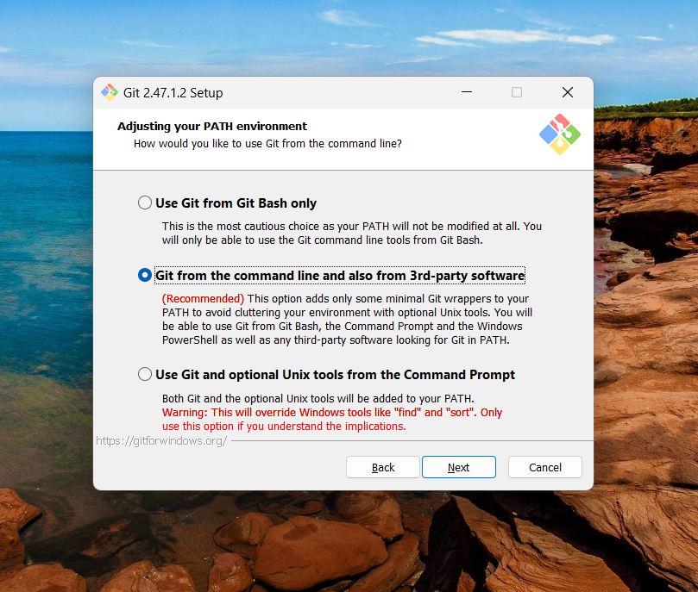

Here, choosing SSH executable which is internal or external.

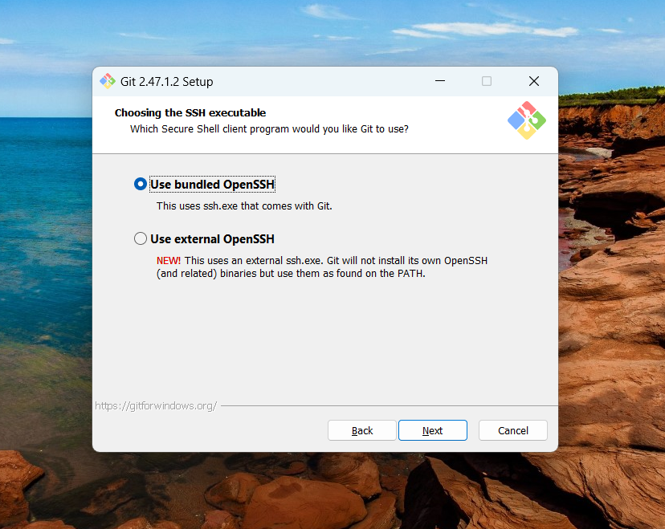

Then you can choose which library can be used.

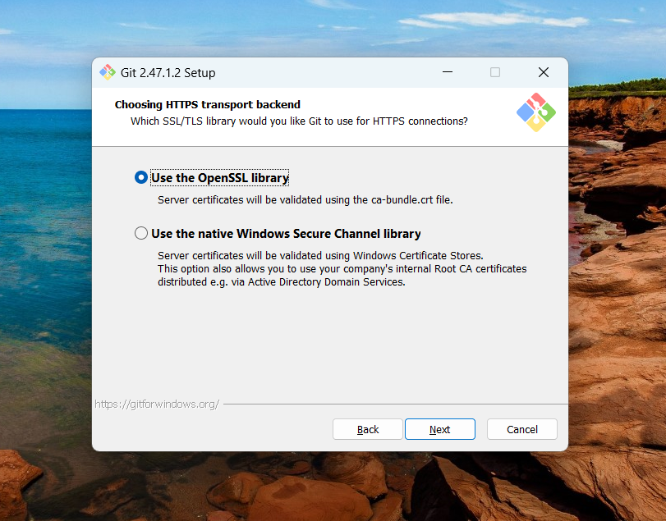

Here the lines that are in text files are configured.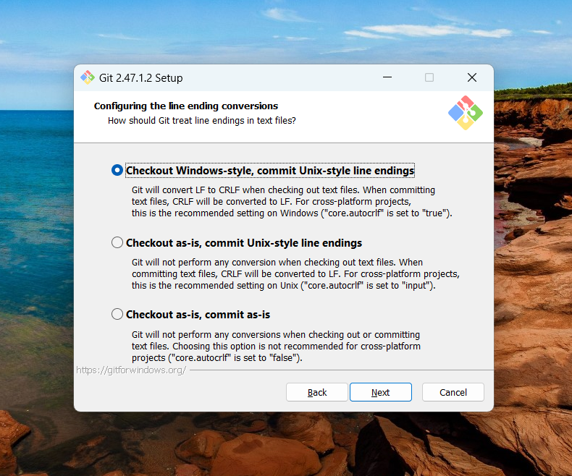

Now you are asked to choose the terminal.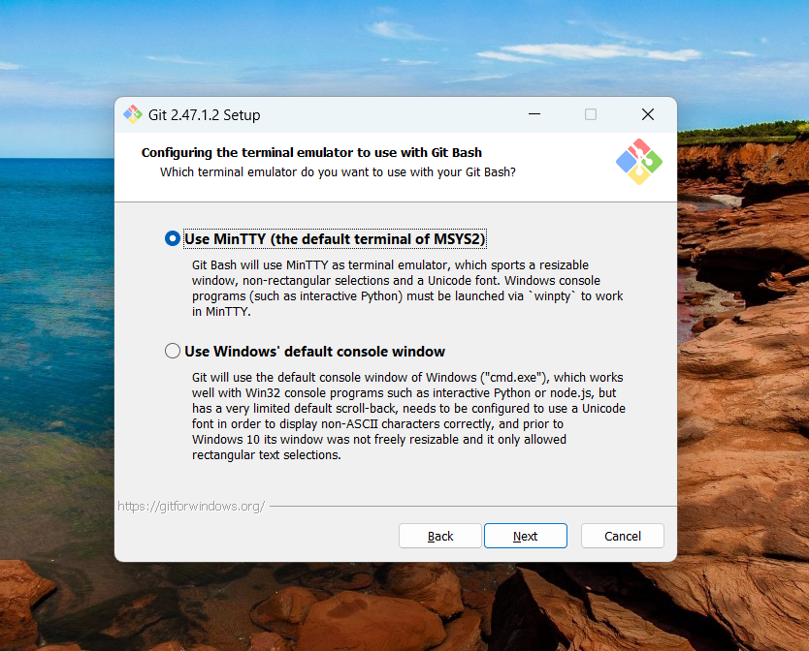Now you choose how data to be fetched to your git.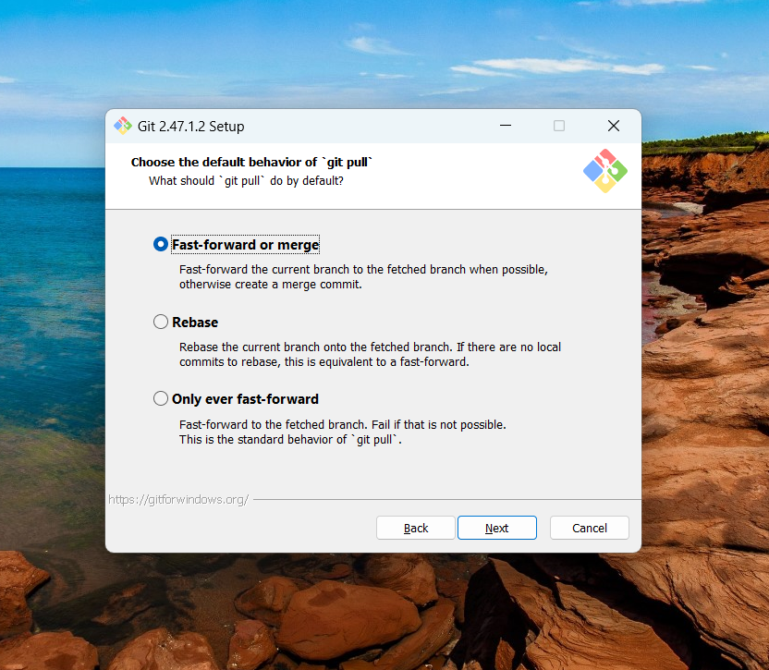

Now you choose the which credential helper should be configured.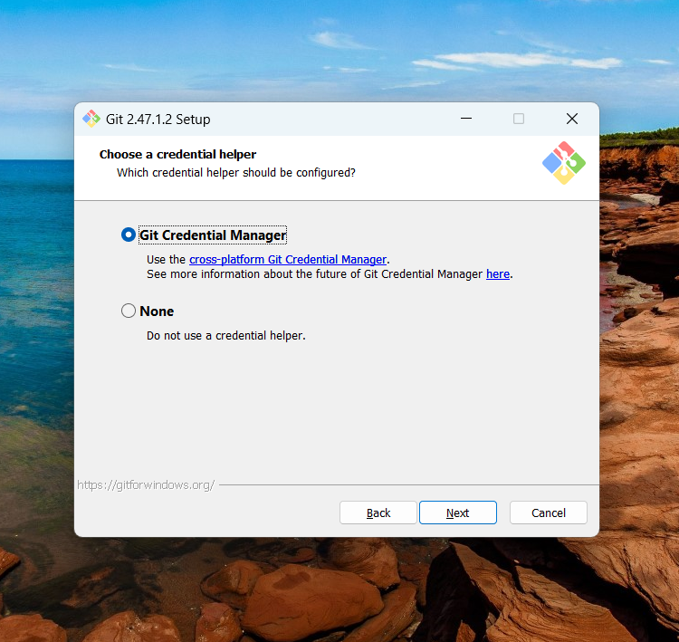

Now you choose the features which are enable to gitbash.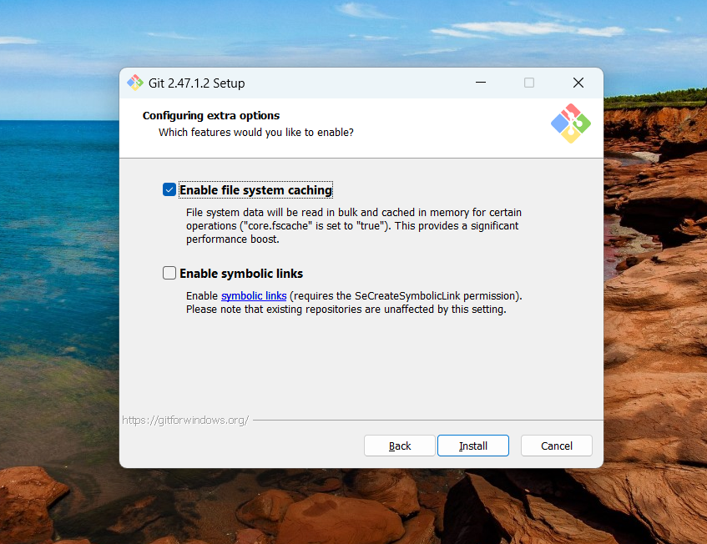

Now ‘Git’ is being installing.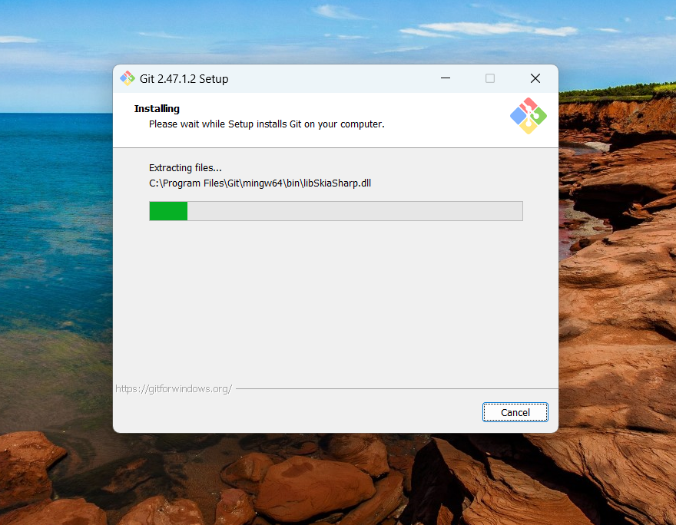

Now ‘Git’ is installed.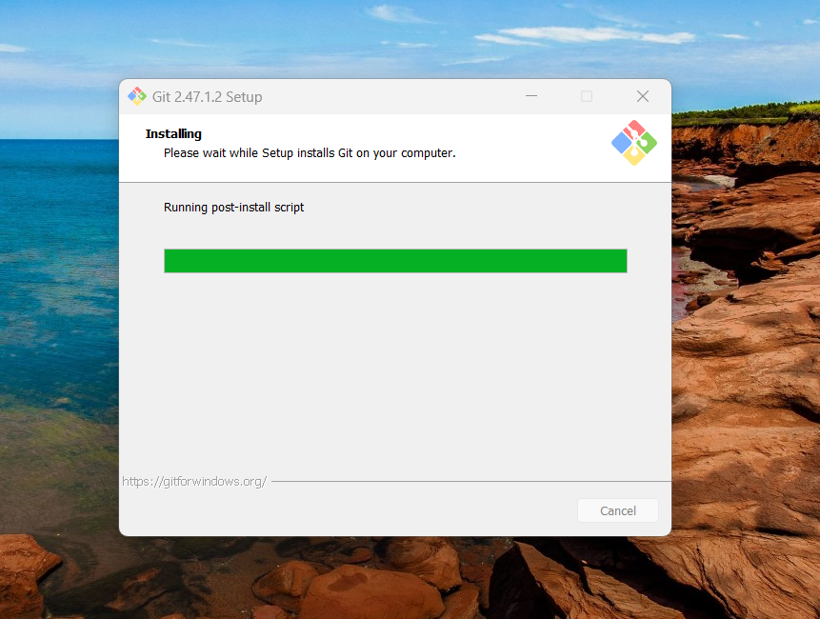

Now the git is been launched.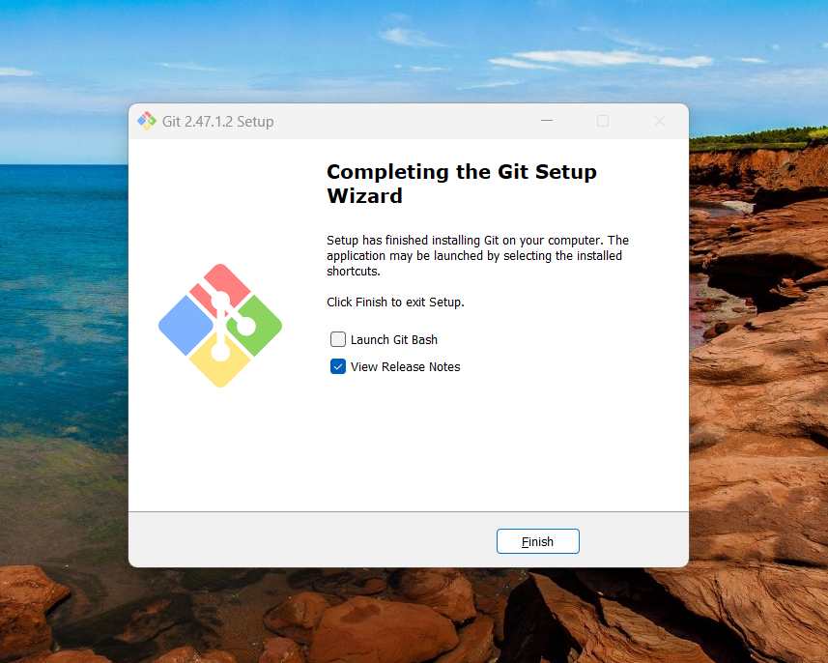

Now you can search ‘git bash’ on your windows.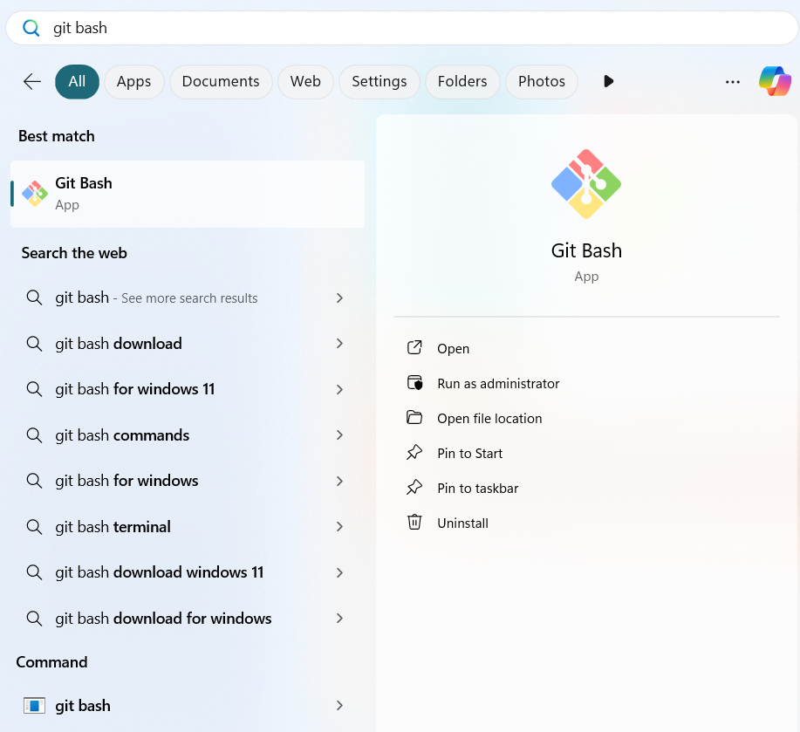

After Git bash is opened ,you can start coding.



Gitbash is opened.

* This shows that in which path we are in.

Raksha@DESKTOP-OEJF5BL MINGW64 ~

$ pwd

/c/Users/Raksha

* After this we have to enter in which drive we have to work.

Raksha@DESKTOP-OEJF5BL MINGW64 /e

$

* Next we need to create a repository by any name.

Raksha@DESKTOP-OEJF5BL MINGW64 /e

$ mkdir L15

* After creating a repo , we must move into its folder to start working inside it.

Raksha@DESKTOP-OEJF5BL MINGW64 /e

$ cd L15

### After this we have to Initialize a Git Repository so ,this is the code for that,

Raksha@DESKTOP-OEJF5BL MINGW64 /e/L15

$ git init

After initializing the repo it will display the master branch.

Raksha@DESKTOP-OEJF5BL MINGW64 /e/L15 (master)

After this we can start the coding or anything with the files.

* To create a file, the git command is

Raksha@DESKTOP-OEJF5BL MINGW64 /e/L15

$ vi test.txt

Any file name can be given based on your project.

* To read the file we use the git command,

Raksha@DESKTOP-OEJF5BL MINGW64 /e/L15

$ cat text.txt

* Next to this we need to add and commit the file.

The commands which we use are

Raksha@DESKTOP-OEJF5BL MINGW64 /e/L15 (master)

$ git add test.txt

warning: in the working copy of 'test.txt', LF will be replaced by CRLF the next time Git touches it

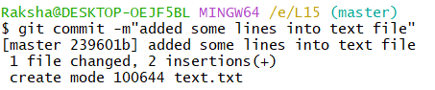

* After this we can create more file with the same command vi(file name)

To create a branch we use the code,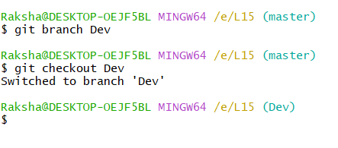

We switched from master branch to Dev branch.After in this branch also we can add files and add and commit also we can do.

The git log --oneline command is used to display a simplified, compact view of the commit history in a Git repository.

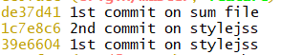

We use the code git diff to the difference between the same files or the different files.

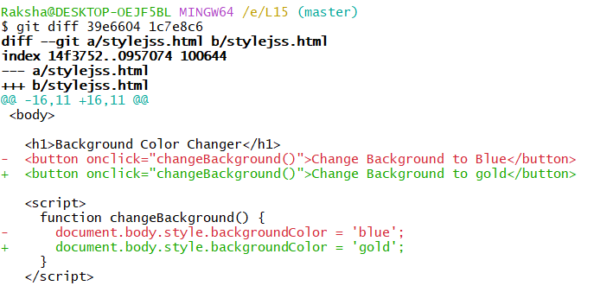

We can see the additions and deletions .

git log --oneline --decorate --graph, This command gives a **compact, visual, and informative** view of the commit history, which is very helpful when working with branches.

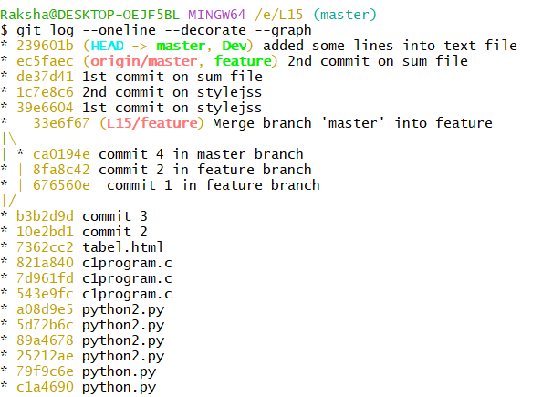

To merge the branches,we use the git command,

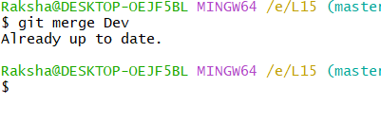

To move from one branch to other branch we use the command,

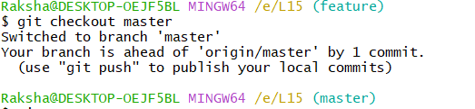

When we merge the branches ,the files will combain together and all files will be in the branch to which branch you merged.

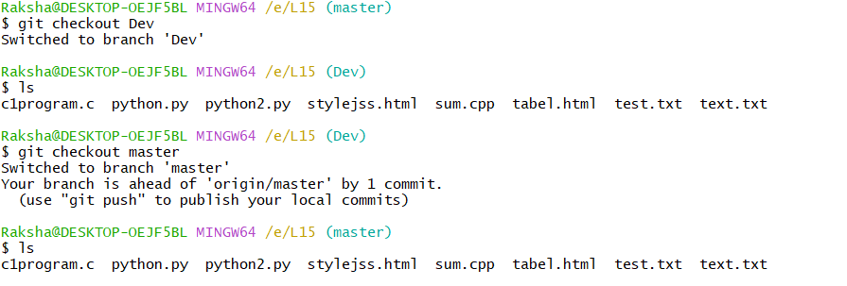

* We use git remote to **connect your local Git repository to a remote repository**, such as one hosted on GitHub, GitLab, or Bitbucket.

|  |
| --- |
| * git remote add origin <url> |

|  |
| --- |
| Connect your local repo to a remote (usually called origin) |

**[git remote add origin** [**https://github.com/username/project.git**](https://github.com/username/project.git)**]**

* To **view the remote repositories** linked to our local Git repository, along with their URLs we use git command,

**git remote –v**

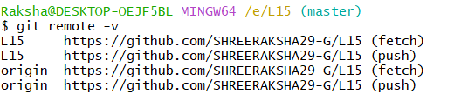

* **Command : git mergetool**

The git mergetool command is used to **resolve merge conflicts** using a graphical or external merge tool.

* **Command : git push –u origin master .**

This command is used to upload local repository content to a remote repository.

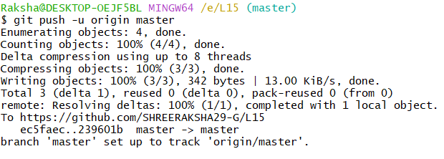

We can see the files in Github.

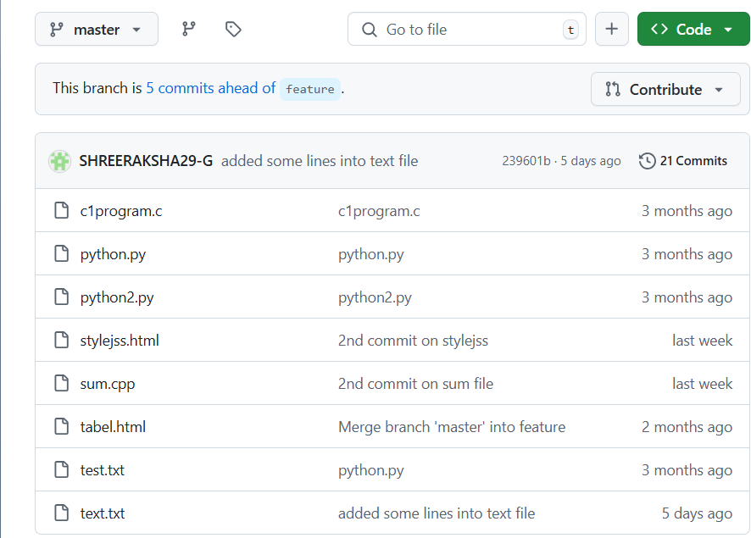

* Fork:

Used to create a personal copy of someone else's repository on our GitHub account.

If we enter into someone’s repo ,in the right side of the pagr we can see the fork box,by clicking that we can create a fork.

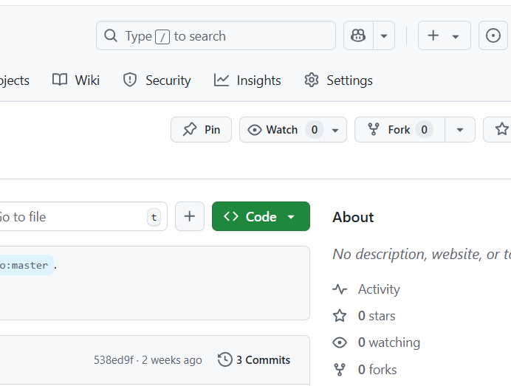

After forking their repo ,we need to copy the url of their repo and in gitbash by using the command git clone<repository-url>,we need to paste the url with that command.



This is the URL we need to copy. This is a sample URL.

After cloning the repository, the files present in it will be available in our own repository. This allows us to edit the files and make necessary changes.

After editing, we need to add the file and commit it. Then, we push the file to GitHub.

Once the file is pushed, the owner of the repository will receive a notification about the pull request. If they accept the pull request, the changes will be successfully merged.

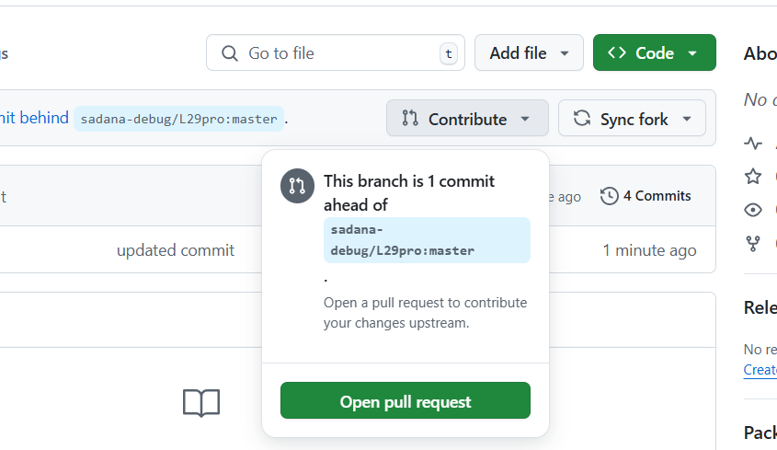 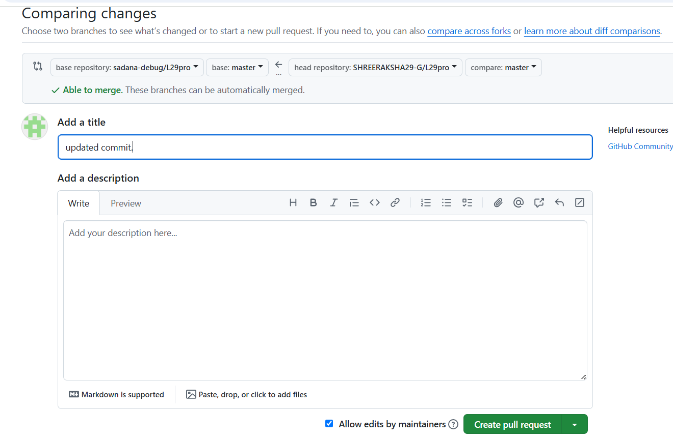

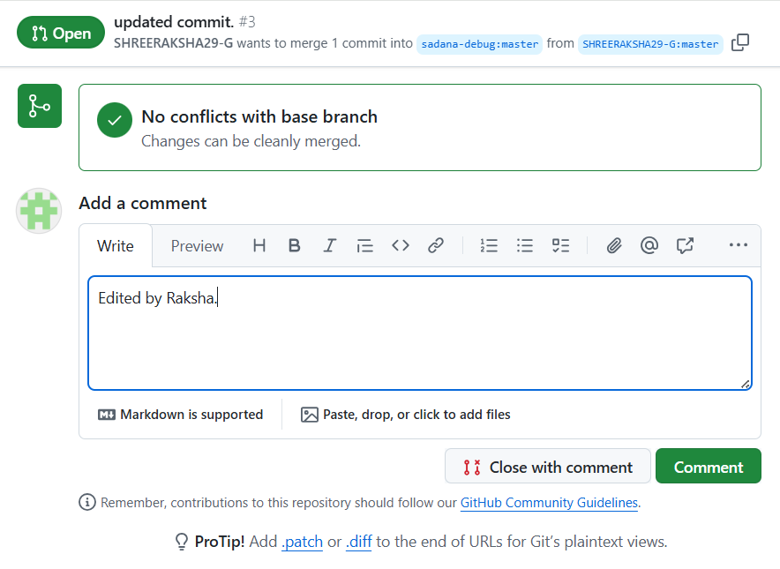

The Team Members of our SCM project are,

G Shree Raksha.

Lakshmi Nair.

Abhipsha Jena.

Spoorthi.

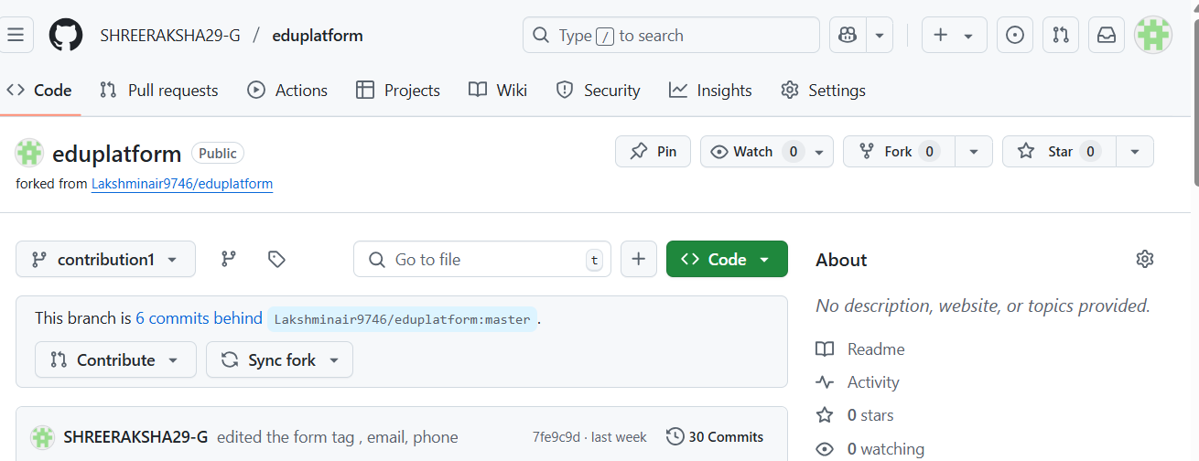

This is the repo which I forked from Lakshmi Nair.

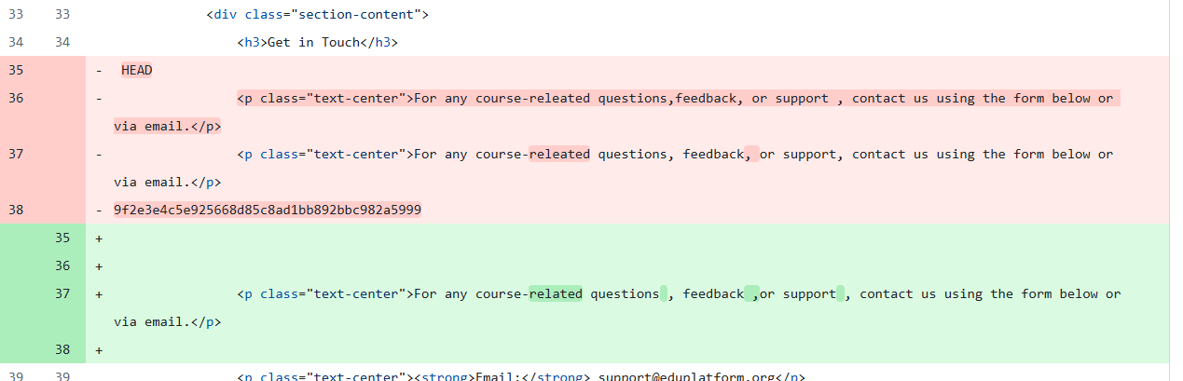

Changes made in the file.

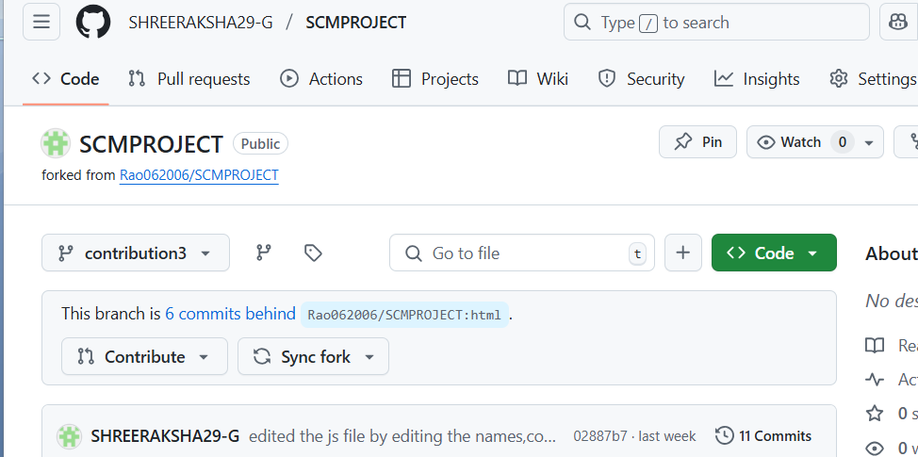

This is the repo I forked from Spoorthi.

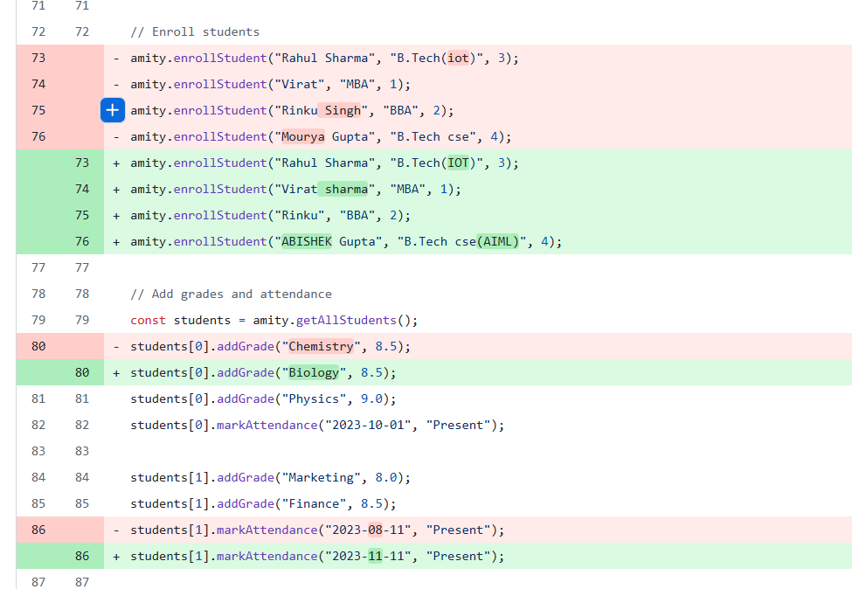

These are the changes I made in her js file.

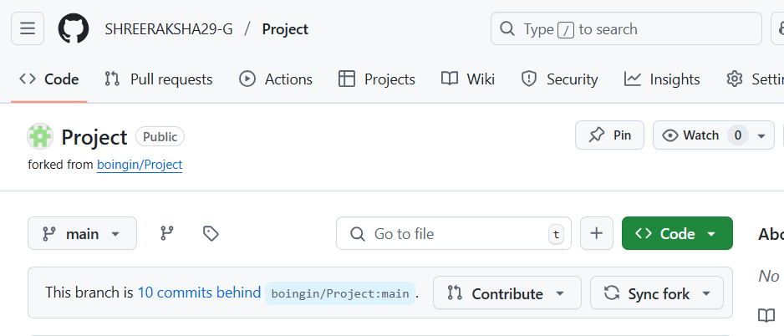

This is the repo which I forked from Abhipsha Jena.

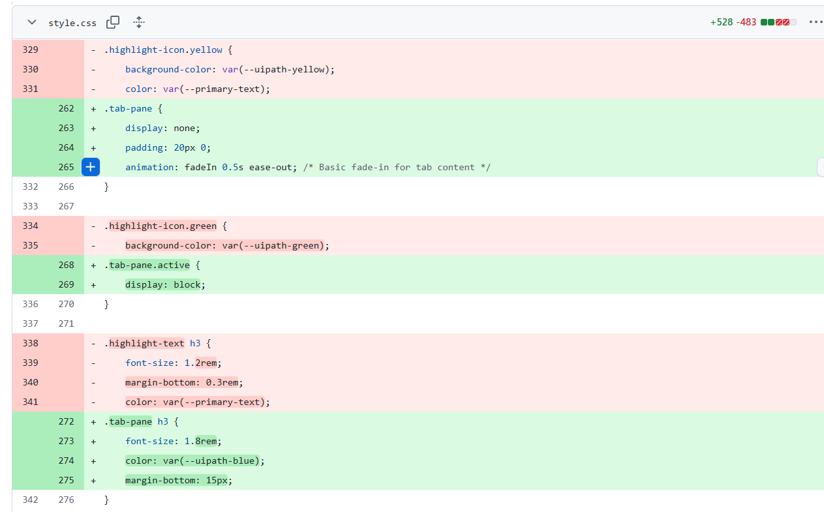

Still the more changes were there ,I pasted the small portion of it.